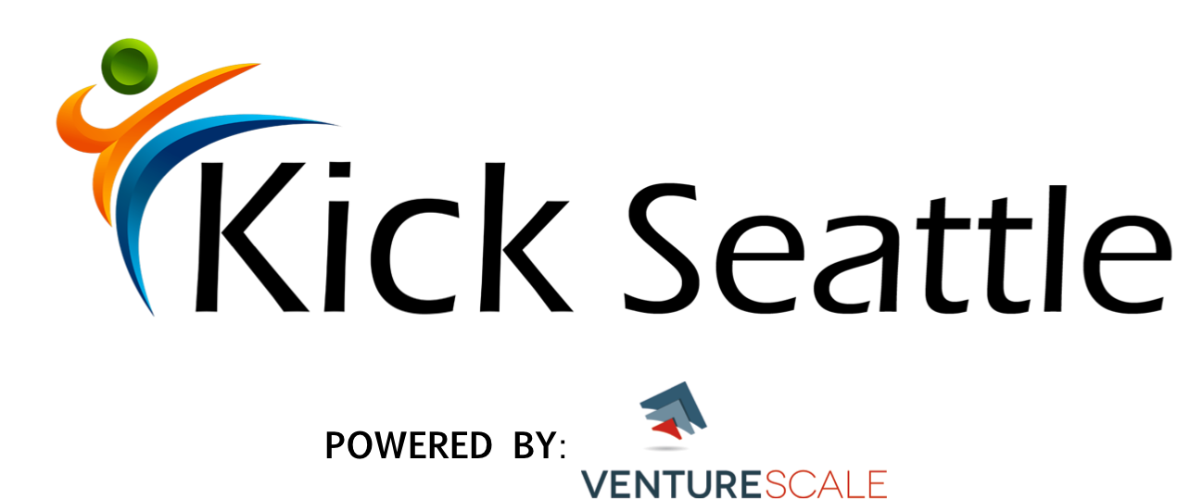

**Dreaming of starting a business?**

**Kick Incubator turns your dreams into a reality**

Kick is the inclusive 6-week cohort driven business incubator. Kick Seattle is open to all business types, so whether you are (or you know someone who is): dreaming of a tech start-up; struggling with a recently started catering business; aspiring to leave your job to start your own marketing firm; an acting ED/board chair of a start-up non-profit; tinkering with a low cost medical device invention, or; in any other similar situation, this course was created for you.

Visit <http://seattle.kickincubator.com>

The applications opened in March and close on April 30th. The course is scheduled to run May 19 to June 26. Kick is a tuition-based incubator model with a twist, whereby we encourage applicants to crowdsource their tuition if they choose. The capacity of the course is limited to 20 individual participants.

Please feel free to contact us with any questions, comments or feedback

[kick-seattle@venturescale.co](mailto:kick-seattle@venturescale.co)

If you are a supporter of entrepreneurship in Seattle please share the message with anyone who needs guidance, advice and support in their new venture.